Note Ten

* Multiple regression
  + Key virtues
  + 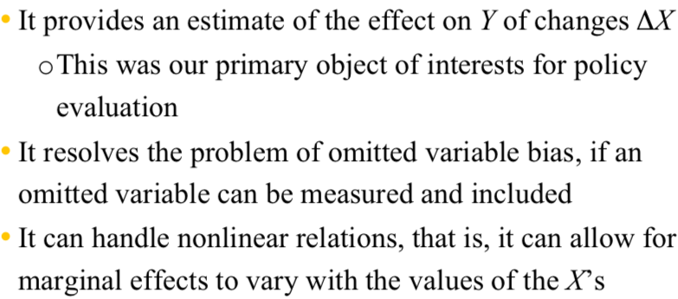
* Internal and external validity
  + 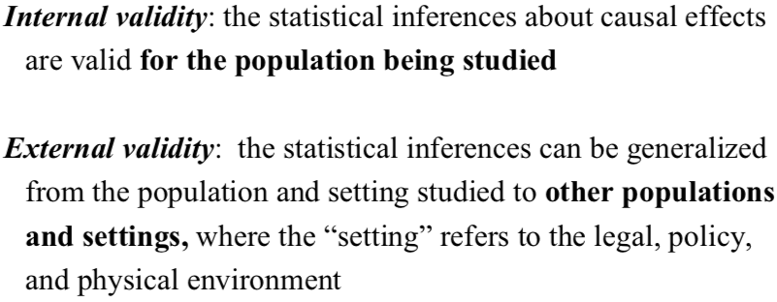
  + Threats
    - External
      * How far can we generalize class size results from california school districts?
    - Internal
      * 1.
        + Bias arises if an omitted variable is both

A determinant of Y

Correlated with at least one of the included regressor

* + - * + Solution

Include as an additional regressor

Run a randomized controlled experiment

* + - * 2.
        + Wrong functional form

Estimate a linear regression when the true relationship is cubic in X

* + - * + Solution

Try alternative nonlinear specifications

* + - * 3.
        + Errors in variables bias

X is measured with errors

Data entry errors

Ambiguous questions problems

* + - * + Solutions

Obtain a better data

Develop a specific model of the measurement error process

* + - * 4.
        + Sample selection bias

Sample is not selected randomly

* + - * + Solution

Collect the sample in a way that avoids sample selection

* + - * 5.
        + Simultaneous causality bias

We assume X → Y, what if Y → X as well?

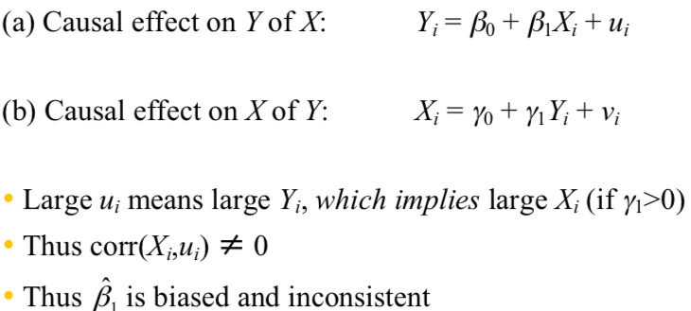

* + - * + Solutions

**Randomized controlled experiment**

Develop and estimate a complete model of both directions of causality